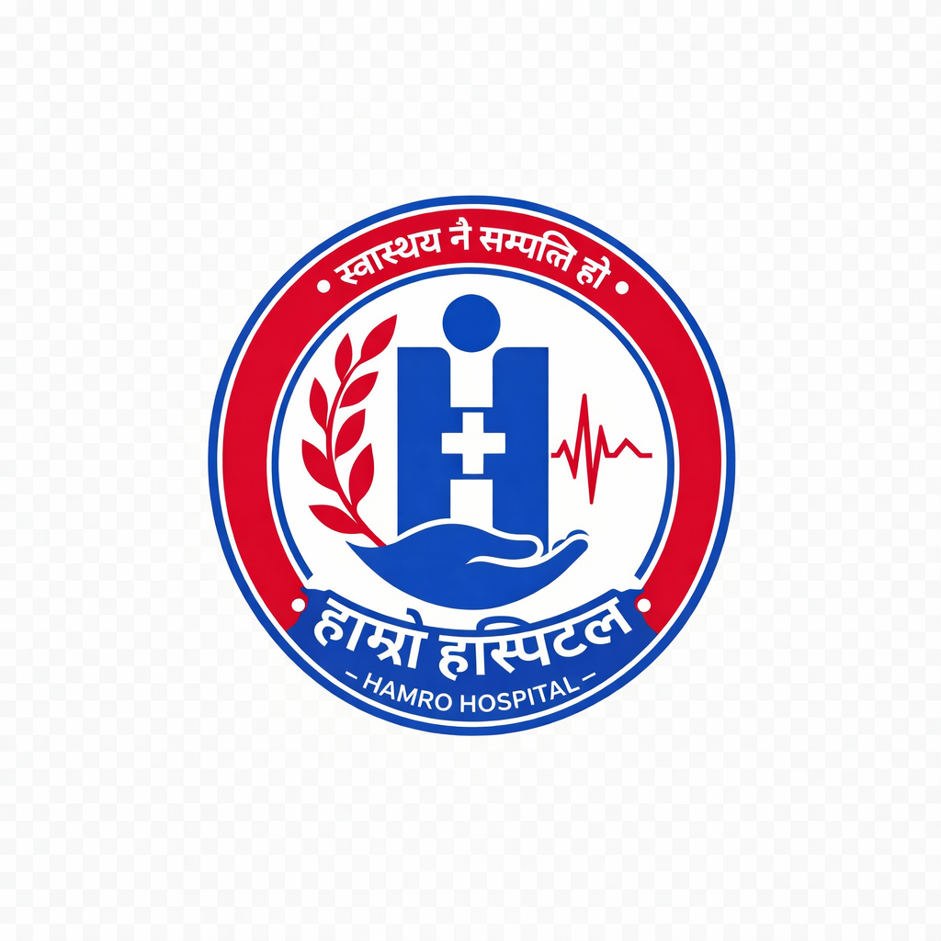

Hamro Hospital Management System – Complete UI/UX & Feature Update Instructions
IMPORTANT
Do NOT redesign the project from scratch.
Keep the existing architecture, color palette, responsiveness, Django backend, and database.
Only improve and extend the existing system while maintaining consistency.
The website and dashboard must feel like one professional Hospital Management System.

1. Branding
- Remove every text logo such as:
  - Hamro Hospital
  - Dashboard Logo Text
- Replace every logo with the hospital logo image that I will provide.
- Use the logo in:
  - Website navbar
  - Dashboard sidebar
  - Login pages
  - OPD Ticket
  - Bill Receipt
  - Patient Card
  - Print pages
  - Reports
Do not stretch or distort the logo.

2. Website Navbar
Improve the navbar.
Required menus:
- Home
- About
- Departments
- Doctors
- Medical Services
- Contact
- Patient Login
- Staff Login
Remove duplicate "Book Appointment" buttons.
Book Appointment should only appear as a primary CTA.

3. Website Theme
Add the missing features from the original template:
- Auto Theme
- Light Theme
- Dark Theme
Include:
- Theme switch button
- Theme persistence
- Responsive behavior
- Smooth transitions

4. Search
Add global website search.
Search should find:
- Doctors
- Departments
- Medical Services

5. Notification
Next to Contact add a Notification icon.
When clicked it opens:
- Online Appointment Available
- eSewa Payment Available
- Hospital Notices
- Holiday Notices
- New Services

6. Chatbot
Add a simple chatbot.
The chatbot can answer:
- Which department should I visit?
- Which doctor treats my disease?
- Doctor schedule
- Available departments
- Hospital services
Example:
User:
"I have Hernia."
Bot:
"Please visit General Surgery."
Then show:
- General Surgery
- Available doctors
- OPD schedule
The chatbot must NOT access patient records.

7. Home Page
Remove unnecessary dashboard example texts.
Remove:
Hamro Hospital Dashboard
Remove:
hamrohospital.com
Keep the page clean.

8. Trusted Communities
Keep:
Kathmandu
Pokhara
Biratnagar
Lalitpur
Bhaktapur
Chitwan
Make them meaningful.

9. Departments
Departments must come from Django Admin.
When Super Admin creates a department:
It automatically appears on the website.
Department page should show:
- Description
- Services
- Available Doctors
- OPD Schedule
- Unit 1
- Unit 2
No consultation price.

10. Medical Services
Create a separate Medical Services page.
Include dummy services:
- Emergency
- General Medicine
- Orthopedics
- ENT
- Neurology
- Neurosurgery
- Cardiology
- Pediatrics
- Gynecology
- Dermatology
- Urology
- Ophthalmology
- Psychiatry
- Dental
- ICU
- Laboratory
- Pharmacy
- Radiology
Each service opens inside the page (accordion/modal), not a separate page.
Show:
Description
Doctors
Schedule
Department
No pricing.

11. Doctors
Show only 10–12 main doctors.
Each doctor profile includes:
- Name
- Department
- Qualification
- Short Introduction
- OPD Days
- OPD Time
- Unit
- Contact (optional)
No consultation fee.
Add doctor search.
Typing "DR R" should immediately filter doctors.

12. Department Details
Clicking a department should expand and show:
Department
Doctors
Unit
Sunday Schedule
Monday Schedule
Tuesday Schedule
Wednesday Schedule
Thursday Schedule
Friday Schedule
Saturday Schedule

13. Responsive Navigation
Whenever opening any popup/page,
Always include:
← Back button
instead of only an X icon.

14. Appointment Section
The homepage Book Appointment is NOT the regular OPD.
It is:
Hospital Extension Service
Rename page title to:
Hospital Extension Service
Fields:
- New Patient / Old Patient
- Department
- Doctor
- Date
- Time
- Notes
- Payment Method
Payment:
- Cash (Default)
- eSewa
Doctor schedules should come from Doctor Admin.
Doctor consultation fee belongs ONLY to Hospital Extension Service.
After booking:
Generate:
- PDF
- Print
- Barcode
- QR Code
NO token number.
Generate unique Hospital Extension Number:
HES000001
HES000002
etc.

15. Patient Login
Create full authentication.
Registration:
- Full Name
- Phone
- OTP Verification
- Password
- Confirm Password
Automatically generate Hospital Number:
HT003001
HT003002
HT003003
After login:
Patient Dashboard should show:
- Profile
- Hospital Number
- Appointment History
- Registration History
- Bills
- Reports
- QR Card

16. Staff Login
Replace navbar Book Appointment duplicate with:
Staff Login
Use professional login page.

17. Dashboard
Keep existing dashboard.
Improve it.
Add:
- Patients
- Departments
- Doctors
- Hospital Data
- Clinical Module
- Staff Management
- Revenue
- Reports
- Django Admin
Patient Management should have its own sidebar menu.

18. Barcode Search
Every patient search box should support:
- Typing
- Barcode Scanner
- QR Scanner
When scanned:
Auto-fill:
- Name
- Age
- Gender
- Phone
- Hospital Number
No manual search required.

19. Patient Card
Patient card should contain:
- Hospital Logo
- Patient Photo
- QR Code
- Barcode
- Hospital Number
- Name
- DOB / Age
- Gender
Professional printable design.

20. Registration Module
Improve registration.
Fields:
Patient Type
- New Patient
- Old Patient
Payment
- Cash
- eSewa
Doctor
Department
Province
District
Municipality
Ward
Address
Phone
Age
Gender
Hospital Number
Province and District must support keyboard search.
Typing:
B → Bagmati
K → Kathmandu
etc.
Doctor dropdown should show:
Dr. Ramesh Sharma
instead of only name.

21. Age Input
Support:
- Days
- Months
- Years
Examples:
10 Days
4 Months
12 Years

22. OPD Ticket
Redesign completely.
Needs:
Hospital Logo
Clean layout
Smaller Token Number
Professional hospital appearance
QR Code
Barcode
Print button
Download PDF

23. Bill Receipt
Redesign professionally.
Include:
Logo
Barcode
QR
Hospital Information
Patient Information
Payment Method
Cleaner layout

24. Revenue
Improve formatting.
Instead of:
1000000
Show:
1,000,000
Large revenue cards should open detailed reports on click.

25. Django Admin Integration
Everything should be manageable from Admin.
Including:
Doctors
Departments
Schedules
Services
Announcements
Notification
Homepage
Hospital Information
Registration Fee
Old Patient Fee
Hospital Extension Fee
Doctor Schedule
Doctor Availability
Website Content

26. Website Dynamic Data
Website should automatically load from database:
Departments
Doctors
Services
Announcements
Schedules
Hospital Information
No hardcoded data except dummy placeholders.

27. Dummy Data
Create realistic demo data.
Departments
15+
Doctors
12
Services
20+
Schedules
Each doctor
Each department

28. UI
Everything must be:
- Mobile responsive
- Tablet responsive
- Desktop responsive
Use:
Smooth animation
Professional hospital appearance
Consistent spacing
Accessible forms
Modern cards
Proper typography
No unnecessary pages
No duplicate buttons
No placeholder dashboard examples

29. Overall Goal
The system should look and behave like a real hospital management platform.
Patients should easily:
- Find departments
- Find doctors
- View schedules
- Register
- Login
- Book Hospital Extension appointments
- Print tickets
- Download PDFs
Staff should efficiently:
- Register patients
- Scan barcodes
- Scan QR codes
- Search instantly
- Manage departments
- Manage doctors
- Generate reports
Everything should be dynamic through Django Admin and maintain the existing architecture while significantly improving usability, responsiveness, and professional quality.


